T-SQL Language Notes (Microsoft SQL Server)

Sources:
- Lynda.com Videos stored C:\DataVideos\Database\SQLServer2008\LyndaSQLServer2008EssentialsDVD\
- SQL Server Unleashed book
- Paragon Corporation web site article
- MS Access binder examples
- Understanding SQL by Martin Gruber
- Train Signal Inc. videos

Also See:

Table of Contents

SQL Language 2
SELECT 3
SELECT FROM 3
Special Operators (IN, BETWEEN, LIKE, NULL) 5
Aggregate Functions 6
Functions in the WHERE Clause 8
GROUP BY 8
HAVING Clause 9
DISTINCT 11
JOINS 11
SUBQUERY 11
INSERT INTO VALUES 12
UPDATE SET 13
DELETE 13
CREATE TABLE 14
Copying a Table 14
ALTER TABLE 14
DROP TABLE 14
Gruber Tables 15

SQL Language
SQL is a declarative language. Programming languages like C or Visual Basic are procedural languages.
With SQL, you don’t need to lay out the algorithm.
Result sets are what SQL SELECT statements return
T-SQL is Microsoft’s flavour of SQL
Keywords in SQL are by convention written in upper case, but will work in any case.

Procedural Language/Structured Query Language (PL/SQL) is Oracle Corporation's procedural extension language for SQL and the Oracle relational database. PL/SQL's general syntax resembles that of Ada or Pascal. It is also one of three key programming languages embedded in the Oracle Database, along with SQL itself and Java.

SSMS Default Database
Security, Logins, name of the person, right-click Properties, set the default database.

Display the Current Database in T-SQL
SELECT DB_NAME() AS [Current Database];
GO

SELECT

SELECT 'Hello World'  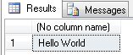  This returns Hello World. Single quotes are required. | SELECT 5,'Hello World'  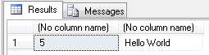  No quotes needed for numbers
SELECT 5,658 AS 'Five Thousand'  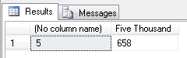 | SELECT 5 AS Number,'hello world' AS Message, 1231 AS Number2  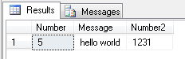
SELECT 5 AS 'Number Five'  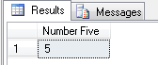  If the column name has a space in it it must be put inside sigle quotes. | SELECT 5 * 3  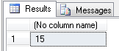
SELECT 5.0 * 3.0  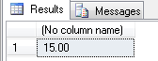 | SELECT 5 * 3 / 2  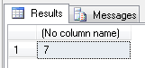  Note that the answer is not 7.5
SELECT 5.0 * 3.0 / 2.0  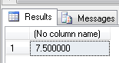 | SELECT 5.0 * 3.0 / 2.0 AS Calculation  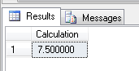
SELECT (5.0 * 3.0 / 2.0) AS Calculation  The same result, with or without brackets | SELECT (1 + 5.0 * 3.0 / 2.0) AS Calculation  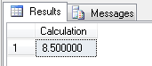  Notice that the order of mathematical operations is used. Addition is done last.
SELECT (1 + 5.0) * 3.0 / 2.0 AS Calculation  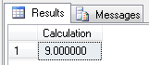 | SELECT LOG(3), 'The log of 3'  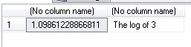  There are also many available functions that are discussed later in this document.

SELECT FROM

Keywords
SELECT is a keyword. FROM is a keyword that needs to be in every query.
SELECT
SELECT * FROM SalesLT.Customer
SELECT FirstName, LastName, EmailAddress FROM SalesLT.Customer

Table Re-naming within SELECT
SELECT * FROM SalesLT.Customer a
WHERE a.CustomerID < 6

DISTINCT
You can eliminate duplicate values from a SELECT clause with DISTINCT. DISTINCT is an argument. You can eliminate redundant data. If you should not have redundant data you should not use DISTINCT because it can hide a problem. You might assume that all of your customer names are different. If someone put a second PORTER in the Customers table and you use SELECT DISTINCT cname, you would not see evidence of the duplication.

DISTINCT can be specified only once in a SELECT statement. If the SELECT has multiple fields, DISTINCT eliminates rows where ALL of the selected fields are identical. Rows in which some values are the same and others are different will be retained and presented in the output. DISTINCT applies to the entire output row, not a specific field (except when used in aggregate functions.

Fields
As shown above, you can choose to output only certain rows of a table by listing them after the SELECT keyword. You can list these fields in any order you wish. It does not have to in the same order as the table.

Records
You can choose to only show some of the records in a table. The WHERE clause of the SELECT command allows you to define a predicate (a condition that can be either true or false) for any row of the table. If it is true, the row is sent to the output.

WHERE Clause
SELECT FirstName, LastName, EmailAddress FROM SalesLT.Customer WHERE LastName =’vargus’
The Collation of the database is by default set to be case insensitive so that Vargus and vargus are equivilant

SELECT FirstName, LastName, EmailAddress FROM SalesLT.Customer WHERE CustomerID = 600

WHERE CustomerID > 600 AND CustomerID < 800

Using Relational and Boolean Operators to Create More Complicated Predicates
Predicates evaluate to true or false.

Relational Operators
A relational operator is a mathematical symbol that indicates a certain type of comparison between two values.
= equal to
> greater than
< less than
>= greater than or equal to
<= less than or equal to
<> not equal to

Boolean Operators
Boolean expressions are those that are either true or false.
AND Takes two Booleans (A AND B) as arguments and evaluates to true if they both are true
OR Takes two Booleans (A OR B) as arguments and evaluates to true if either is true
NOT Takes a single Boolean (NOT A) as an argument and changes the value from false to true or true to false
Other more complicated operators exist (such as exclusive or), but these can be built from our three simple pieces.

Show all the customers in Toronto who have a rating of over 200
WHERE city = ‘Toronto’ AND rating > 200

Show all customers who are either in Toronto or have a rating of over 200
WHERE city = ‘Toronto’ OR rating > 200
In this example, all we need is for at least one argument to be true. Therefore all of the Toronto records are shown and also those records that have a rating of greater than 200.

NOT
Notice that the NOT operator must precede a Boolean whose value it is to change. It is incorrect to write rating NOT > 200. It should be written as NOT rating > 200.

Parentheses
WHERE NOT city = ‘Toronto’ OR rating > 200
Does the NOT apply only to the city = ‘Toronto’ expression or to both expressions? The answer is the former. SQL will apply NOT to the Boolean expression immediately following it only. Use parentheses if you want to include both expressions in this case. Parentheses mean that everything inside them will be evaluated first and treated as a single expression.

Special Operators (IN, BETWEEN, LIKE, NULL)
In addition to the relational and Boolean operators, SQL uses four special operators: IN, BETWEEN, LIKE and IS NULL.

IN
WHERE LastName IN (‘Titan’, ‘Clark’, ‘Harding’)
This will return all those with these last names. IN explicitly defines a set of values.
Instead of using WHERE city = ‘Toronto’ OR city = ‘Vancouver’
We could use
WHERE city IN (‘Toronto, ‘Vancouver’)

For numbers we don’t need the quote as shown here: WHERE amt IN (245, 43, 192)

BETWEEN
WHERE CustomerID BETWEEN 600 AND 800
BETWEEN is inclusive meaning that is does include 600 and 800

SQL does not support a noninclusive BETWEEN. You have two options. Either define the boundary such that inclusive is acceptable or do the following:
WHERE (amount BETWEEN .1 AND .12) AND NOT amount IN (.1, .12)

Alpha is Inclusive – Not Inclusive
WHERE LastName BETWEEN ‘a’ AND ‘c’
This will return all of the last names beginning with a and b but not with c.
Why? This is because of the way BETWEEN compares strings of unequal lengths. The string ‘c’ is shorter than the string Carter, so BETWEEN pads the c with blanks. The blanks precede the letters in alphabetical order (in most SQL implementations), so Carter is not selected. Therefore consider going beyond the last letter. Use the letter z. If you want to include all of the last names that start with z, then use several z’s.

WHERE LastName BETWEEN ‘ad’ AND ‘c’
This will return all of the last names beginning with ad and b but not with c.

LIKE
WHERE CompanyName LIKE ‘Metro%’
WHERE CompanyName LIKE ‘_etro%’
The percent character represents anything (any sequence of any number of characters including zero characters)
The underscore character represents any single character

CHAR and VARCHAR
The % wildcard at the end of the string is necessary in many implementations if the length of the field is greater than the number of characters in the data. For CHAR, the name ABC Inc. is stored in the field followed by a series of spaces. This would not be necessary if the field were of type VARCHAR.

Searching for a percent or underscore character

IS NULL, IS NOT NULL
WHERE MiddleName IS NULL

ORDER BY
SELECT ProductID, Name, Color, ListPrice
FROM SalesLT.Product
ORDER BY ListPrice

The default order is Ascending
For Descending, use DESC

Multiple columns to order on. The first one listed is priority.

TOP
SELECT TOP 10
SELECT TOP 25 PERCENT
SELECT TOP 1

SELECT TOP 1 will return one row, even if there are two or more rows with the same value

Aggregate Functions
Most functions return scalar values (single values). Some functions return more than that.
COUNT, SUM, AVG, MAX and MIN.
Only numeric fields can be used for SUM and AVG.
For COUNT, MAX and MIN, numeric or character fields can be used.

COUNT()
USE MoviesSSISFromExcel
SELECT COUNT(*) FROM dbo.Movie
This will return a number: 556
We therefore know that we have 556 rows in this table.

USE AdventureWorksLT
SELECT COUNT(*) FROM SalesLT.Product
This will return 295.

COUNT(Color)
This will return 245.
If you pick a column, such as the Color column, you may get a different result than using the asterisk. If there are any NULL values they will be ignored when you specify a column name instead of an asterisk. Use the asterisk to be sure to get everything when you want all of the rows to be counted.

SELECT COUNT(Color) FROM SalesLT.Product WHERE Color = 'red'
This will return 38, which is the number or Red products.

SELECT COUNT(*) FROM SalesLT.Product WHERE Color = 'red'
This will return 38 also.

SELECT COUNT(*) FROM SalesLT.Product WHERE Color IS NULL
This will return 50.

However,
SELECT COUNT(Color) FROM SalesLT.Product WHERE Color IS NULL
This will return 0.

SELECT COUNT(*) FROM SalesLT.Product WHERE Color = 'red' OR Color = 'blue'
This will return 64.
SELECT COUNT(*) FROM SalesLT.Product WHERE Color IN('red','blue')
This will also return 64.

SELECT COUNT(*), Color FROM SalesLT.Product
Will return the following error
Column 'SalesLT.Product.Color' is invalid in the select list because it is not contained in either an aggregate function or the GROUP BY clause.

Count the number of different values in a given field
SELECT COUNT (DISTINCT salespersonnumber) FROM Orders

Count the total number of rows in a table
SELECT COUNT(*) FROM Customers
COUNT with an asterisk includes both NULLs and duplicates. For this reason it produces a higher number than the COUNT of a particular field, which eliminates all rows that have redundant or NULL data in that field.

MAX()
SELECT MAX(Minutes) FROM MoviesSSISFromExcel.dbo.Movie

Combining more than One Function
SELECT COUNT(*), MAX(Minutes) FROM MoviesSSISFromExcel.dbo.Movie

Giving the Values Column Names
SELECT COUNT(*) AS TotalNumMovies, MAX(Minutes) AS MostMinutesInAMovie FROM MoviesSSISFromExcel.dbo.Movie

SELECT MAX(ListPrice) AS MaxPrice, MIN(ListPrice) AS MinPrice, AVG(ListPrice) AS AvgPrice
FROM SalesLT.Product
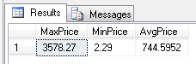

SUM()
SELECT SUM(Minutes) AS TotalMinutes FROM MoviesSSISFromExcel.dbo.Movie

GETDATE()
You do not pass anything into this function, but you need the two parentheses nevertheless.

Parenthesis, @ Signs and Nothing
Most functions have parenthesis. Some functions do not have parenthesis but have two @ signs in front of them. There are a few functions that just use the name and nothing else. SSMS has several functions with two @ signs that fall under the Configuration section. What follows are some examples.
@@VERSION
@@ServerName
@@Language us_english
CURRENT_USER dbo

All of these functions give you something back.

SELECT GETDATE(), @@LANGUAGE, CURRENT_USER
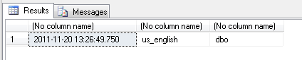

Where Can You Use Functions?
SELECT statements
WHERE clauses
UPDATES
INSERTS

SELECT @@VERSION, @@SERVERNAME, @@CONNECTIONS
Note that you can use several, separated by a comma and you don’t need a FROM statement or in this case you don’t even need the USE statement.

String Functions
You can use these in SELECT statements
USE AdventureWorksLT
SELECT LastName FROM SalesLT.Customer
SELECT FirstName + ‘ ‘ + UPPER(LastName) AS FullName FROM SalesLT.Customer
SELECT FirstName, LEN(FirstName) FROM SalesLT.Customer
SELECT MAX(LEN(FirstName)) FROM SalesLT.Customer

Functions in the WHERE Clause

SELECT FirstName FROM SalesLT.Customer ORDER BY LEN(FirstName) DESC

Here is another one. It doesn’t work.
SELECT FirstName, LEN(FirstName) FROM SalesLT.Customer WHERE LEN(FirstName) = MAX(LEN(FirstName))

The above query returns the error:
An aggregate may not appear in the WHERE clause unless it is in a subquery contained in a HAVING clause or a select list, and the column being aggregated is an outer reference.

SELECT FirstName, LEN(FirstName) FROM SalesLT.Customer WHERE LEN(FirstName) IN (SELECT MAX(LEN(FirstName)) FROM SalesLT.Customer)
The above query returns the following results:
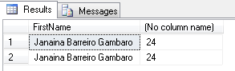
Why two rows? Duplicates in the database. Let’s add the customer ID to our query and check to see what’s happening.

SELECT CustomerID, FirstName, LEN(FirstName) FROM SalesLT.Customer WHERE LEN(FirstName) IN (SELECT MAX(LEN(FirstName)) FROM SalesLT.Customer)
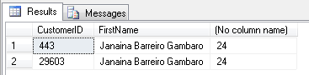
Okay. We have more than one.

Date and Time Functions
See video – some examples

User-Defined Functions

GROUP BY
GROUP BY is a clause. It allows you to define a subset of the values in a particular field in terms of another field and apply an aggregate function to the subset.

Gruber in MS Access:
SELECT Orders.snum, Max(Orders.amt) AS MaxOfamt
FROM Orders
GROUP BY Orders.snum;

Gruber in Book:
SELECT snum, MAX(amt) FROM Orders GROUP BY snum;

The MS Access Output is
Query2
snum | MaxOfamt
1001 | $9,891.88
1002 | $5,160.45
1003 | $1,713.23
1004 | $1,900.10
1007 | $1,098.16
This returns the maximum amouts for each salesperson.
GROUP BY is “for each”.
A group in this case is defined as all of the rows with the same snum value.
GROUP BY applies the aggregate functions indepenently to each group.
In this case there are 5 groups and there can be by definition only one value per output group and only one value per aggregate function.

Multiple Fields
You can use GROUP BY with multiple fields.

SELECT Orders.snum, Orders.odate, Max(Orders.amt) AS MaxOfamt
FROM Orders
GROUP BY Orders.snum, Orders.odate;
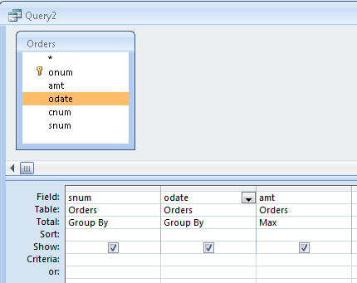 | 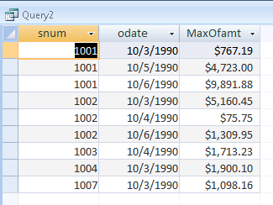

HAVING Clause
Suppose you only wanted just the maximum purchases over $3000.
The HAVING clause defines criteria used to eliminate certain groups from the output, but the WHERE clause defines criteria used to eliminate certain rows from even being processed. The WHERE clause is evaluated for each row of the table but the HAVING clause waits until the end of all of the row processing before executing its criteria.

SELECT Orders.snum, Orders.odate, Max(Orders.amt) AS MaxOfamt
FROM Orders
GROUP BY Orders.snum, Orders.odate
HAVING (((Max(Orders.amt))>3000));

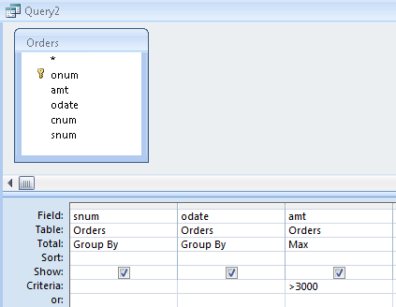 | 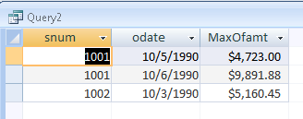

SELECT Orders.snum, Orders.odate, Max(Orders.amt) AS MaxOfamt
FROM Orders
WHERE (((Orders.odate)=#10/3/1990#))
GROUP BY Orders.snum, Orders.odate
HAVING (((Max(Orders.amt))>3000));
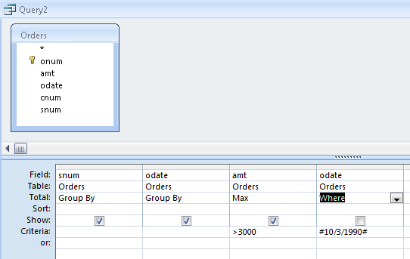 | 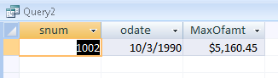

USE AdventureWorksLT
SELECT COUNT(*), Color FROM SalesLT.Product GROUP BY Color
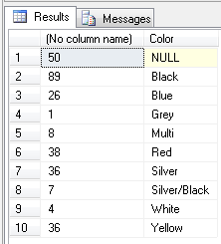

SELECT COUNT(*), Count(Color) FROM SalesLT.Product
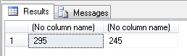
The above query puts Color into an aggregate function. There are 295 rows in the table. There are 245 with non-NULL value in the Color field.

DISTINCT
SELECT CountryRegion FROM SalesLT.Address
Returns 450 rows

SELECT DISTINCT CountryRegion FROM SalesLT.Address
Returns 3 rows

SELECT COUNT(DISTINCT CountryRegion) FROM SalesLT.Address
Retuns the number 3

SELECT DISTINCT CountryRegion, StateProvince FROM SalesLT.Address
Returns 25 rows, part of which is shown below:
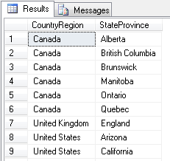

Does the word DISTINCT apply to CountryRegion and StateProvince or just CountryRegion in the above query?

SELECT CountryRegion, StateProvince FROM SalesLT.Address
GROUP BY CountryRegion, StateProvince
Returns the same thing as the above query.

Finding Duplicates
What exactly isw a duplicate record? If you have a list of Movies, a duplicate could be defined as more than one record in the table aving the same movie title. However, there are movies such as The Manturian Candidate that have the same title but were made in the years 1962 and 2004. Selecting one field such as the Title may not be enough to identify dupicate records. What if you haqve 2 copies of exactly the same movie? If there is no quantity field, then you may need to enter the same movie twice.

USE Movie;
SELECT COUNT(Title) AS 'quantity' , Title, YEAR
FROM Movies
GROUP BY Title, YEAR
HAVING COUNT(Title) > 1
ORDER BY Title ASC;

Some rules for the above query:
Use HAVING with GROUP BY
After the word HAVING, use COUNT(Columnname)… instead of ‘quantity’
Make sure all of the non-aggregated column names are included after the word GROUP BY.

2 | Blazing Saddles | 1974
2 | Lord of the Rings: I The Fellowship of the Rings | 2001
2 | Lord of the Rings: II The Two Towers | 2002
2 | Lord of the Rings: III The Return of the King | 2003
2 | Man Who Knew Too Much | NULL
2 | Mr. Moto's Last Warning | NULL
2 | Pan's Labyrinth (English Subtitles) | 2006

Finding Duplicates Using MS Access
Table1
FirstName | Amount
Mike | 23
Bob | 45
Sam | 12
Bob | 224
Sally | 342
Mike | 122
Bob | 10

SELECT FirstName, COUNT(FirstName) AS NumRows
FROM Table1
GROUP BY FirstName
HAVING FirstName IN (
SELECT FirstName FROM Table1
GROUP BY FirstName
HAVING COUNT(*)>1)
ORDER BY COUNT(FirstName) DESC;

The above query produces the following output

qryDuplicates
FirstName | NumRows
Bob | 3
Mike | 2

To simplify the above query you could do this

SELECT FirstName
FROM Table1
WHERE FirstName IN (
SELECT FirstName FROM Table1
GROUP BY FirstName
HAVING COUNT(*)>1)

To produce the following output
qryDuplicates2
FirstName
Mike
Bob
Bob
Mike
Bob

JOINS

SUBQUERY
A subquery is a query within a query. The subquery is executed first. This will be built up gradually to make it easy to understand. The example of Customers and their orders. Customers can have many orders. We are interested in the customer who placed the biggest order. The table is called SalesOrderHeader.

Inner Query
Outer Query

USE AdventureWorksLT
SELECT TOP 1 CustomerID
FROM SalesLT.SalesOrderHeader
ORDER BY TotalDue DESC
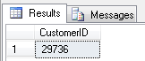
However we need to also get the customer information. The SalesOrderHeader only stores the CustomerID. One way to do this is to JOIN the tables together as follows.

SELECT TOP 1 a.CustomerID
FROM SalesLT.SalesOrderHeader a INNER JOIN SalesLT.Customer b
ON a.CustomerID = b.CustomerID
ORDER BY TotalDue DESC

Now that we have joined them, we can ask for some more Customer information as follows.
SELECT TOP 1 a.CustomerID, b.CompanyName, b.FirstName, b.LastName
FROM SalesLT.SalesOrderHeader a INNER JOIN SalesLT.Customer b
ON a.CustomerID = b.CustomerID
ORDER BY TotalDue DESC
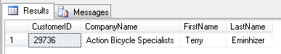

Using a Subquery instead of a Join
SELECT FirstName, LastName, CompanyName
FROM SalesLT.Customer
WHERE CustomerID = (
SELECT TOP 1 CustomerID
FROM SalesLT.SalesOrderHeader
ORDER BY TotalDue DESC)

Another Subquery Example
We want a list of the customers who have never ordered anything. If they have never ordered anything, their customer ID will not appear in the Sales Order table. First, go through the Orders and get a list of all customer IDs that have ordered and then go to the Customer table and list all of the customers that are NOT in that list.

SELECT FirstName, LastName, CompanyName
FROM SalesLT.Customer
WHERE CustomerID NOT IN(
SELECT DISTINCT CustomerID
FROM SalesLT.SalesOrderHeader)

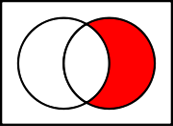
The orders table is represented on the left and the Customers table is on the right.

INSERT INTO VALUES
USE AdventureWorksLT
INSERT INTO SalesLT.ProductCategory
(ParentProductCategoryID, Name)
VALUES
(1, 'Hybrid Bikes')

What if your data includes single quotes? You need to use two single quotes. Do not use double quotes.
INSERT INTO SalesLT.ProductCategory
(ParentProductCategoryID, Name)
VALUES
(1, 'Boy''s Bikes'), (2, 'Girl''s Bikes')
MySQL – You may be able to escape it in MySQL by replacing single quotes with \’

What if there is missing data? If it is okay for there to be missing data in a certain field such as the middle initial of someone, and you still want to add the record, how do you write the SQL statement? Use NULL without any single quotes.
INSERT INTO SalesLT.ProductCategory
(ParentProductCategoryID, Name)
VALUES
(1, 'Boy''s Bikes'), (2, NULL)

MS Excel
If the data you need to enter into a table is in Excel, one way to avoid re-typing the data is to create an INSERT INTO SQL statement to enter the data.
Please refer to the Excel file ExcelInsertIntoSQLString.xlsx

Excel Example Table Called Person
FirstName | LastName | Amount
Mike |  | 35.67
Jeanette | Pennie | 23.87
Ty | Duggan | 56.23
Sam | O'Connor | 67.01

INSERT INTO Person (FirstName, LastName, Amount) VALUES
('Mike',NULL,35.67),
('Jeanette','Pennie',23.87),
('Ty','Duggan',56.23),
('Sam','O''Connor',67.01);

Run the above SQL statement in MS Access to insert the data into the Access table called Person.

What if you want to insert values from a SELECT statement?

UPDATE SET
USE AdventureWorksLT

UPDATE SalesLT.ProductCategory
SET ParentProductCategoryID = 1
WHERE ProductCategoryID = 55

DELETE
DELETE FROM SalesLT.ProductCategory
WHERE ProductCategoryID = 59

OUTPUT
INSERT INTO SalesLT.ProductCategory
(ParentProductCategoryID, Name)
OUTPUT inserted.ProductCategoryID
VALUES (1, 'Commuter Bikes')
Instead of just getting, in SSMS, 1 row(s) affected message, this ne gives us the Product category ID number.

The output can send out more than one piece of information as follows:
INSERT INTO SalesLT.ProductCategory
(ParentProductCategoryID, Name)
OUTPUT inserted.ProductCategoryID, inserted.rowguid
VALUES (1, 'Custom Bikes')
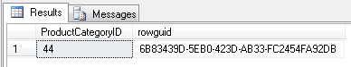

Output also works with the DELETE statement.
Ouput can be used on UPDATE statement, but it may not be what you are expecting.

CREATE TABLE

CREATE TABLE <table name>
(column name> <data type>[(size)],
(column name> <data type>[(size)],…);

CREATE TABLE Salespeople
(snum integer,
sname char(10),
city char(10),
comm decimal);

MS Access
The above command will not work in MS Access unless you change decimal to float, double or single. This has been tested and it will work in Access using “float” but it will create a data type of Double. Using char creates a field type of Text with the specified Field Size of 10 in this case. Specifying integer in the create table statement creates a field type of number with a field size of Long Integer.

Creating an auto-increment column.
CREATE TABLE Actor (ActorID int IDENTITY(1,1) PRIMARY KEY, ActorName char(255))

Copying a Table
What is the best way to simply make a copy of a table and give it a new name?
You might imagine this would work: CREATE TABLE SalesPeopleCopy FROM SalesPeople;

Using SELECT with INTO with SQL Server
SELECT INTO is the way to do this.
SELECT * INTO NewTable FROM MyTable

SQL Server Movies Database Example:
This example assumes that the table has already been created and you wish to copy from one table to another table.
INSERT INTO Movie (Title, Genre, Directors, YearReleased, MinutesLength)
SELECT Title, Genre, Directors, YEAR, Minutes
FROM Movies

You may want to first check to see that the table Movie exists and that it contains no rows from another insert operation. You would probably want to write a stored procedure to do this.

ALTER TABLE
This command is not part of the ANSI standard, but it is widely available, and its form is fairly consistent, although its capabilities vary considerably.

DROP TABLE

Here is a simple example of deleting a table if it exists.
USE Movie;
IF EXISTS (SELECT * FROM sysobjects WHERE name='Actor' AND xtype='U')
DROP TABLE Actor

To delete a table called Actor, use DROP TABLE Actor

If you Script Table as DROP and CREATE To
USE [AdventureWorksLT]
GO

/****** Object: Table [dbo].[ListNames] Script Date: 12/05/2011 20:32:36 ******/
IF EXISTS (SELECT * FROM sys.objects WHERE object_id = OBJECT_ID(N'[dbo].[ListNames]') AND type in (N'U'))
DROP TABLE [dbo].[ListNames]
GO

USE [AdventureWorksLT]
GO

/****** Object: Table [dbo].[ListNames] Script Date: 12/05/2011 20:32:36 ******/
SET ANSI_NULLS ON
GO

SET QUOTED_IDENTIFIER ON
GO

CREATE TABLE [dbo].[ListNames](
[FirstName] [nchar](10) NULL,
[Age] [int] NOT NULL
) ON [PRIMARY]

GO

Gruber’s Tables

Orders
onum | amt | odate | cnum | snum
3001 | $18.69 | 10/3/1990 | 2008 | 1007
3002 | $1,900.10 | 10/3/1990 | 2007 | 1004
3003 | $767.19 | 10/3/1990 | 2001 | 1001
3005 | $5,160.45 | 10/3/1990 | 2003 | 1002
3006 | $1,098.16 | 10/3/1990 | 2008 | 1007
3007 | $75.75 | 10/4/1990 | 2004 | 1002
3008 | $4,723.00 | 10/5/1990 | 2006 | 1001
3009 | $1,713.23 | 10/4/1990 | 2002 | 1003
3010 | $1,309.95 | 10/6/1990 | 2004 | 1002
3011 | $9,891.88 | 10/6/1990 | 2006 | 1001

Customers
cnum | cname | city | rating | snum
2001 | Hoffman | London | 100 | 1001
2002 | Giovanni | Rome | 200 | 1003
2003 | Lui | San Jose | 200 | 1002
2004 | Grass | Berlin | 300 | 1002
2006 | Clemens | London | 100 | 1001
2007 | Pereira | Rome | 100 | 1004
2008 | Cisneros | San Jose | 300 | 1007

Salespeople
snum | sname | city | comm
1001 | Peel | London | 0.12
1002 | Serres | San Jose | 0.13
1003 | Axelrod | New York | 0.1
1004 | Motika | London | 0.11
1007 | Rifkin | Barcelona | 0.15

